**Executive Summary**

|  |  |
| --- | --- |
| To: | John Smart, S-Mart  700 S-Mart Way, Alma, Michigan 12345  1-445-356-2904 |
| From: | **Operation: Dev**  **Columbus, Ohio 43215** |

The purpose of this document is to propose an IT solution for the national supermarket store S-Mart, headquartered at 700 S-Mart Way, Alma, Michigan, 12345. It is Operation: Dev’s, understanding that S-Mart has been having trouble acquiring new customers and have been losing a portion of their existing customers. S-Mart's owner, John Smart, has contacted Operation: Dev to provide various services to re-organize and modernize their IT systems and connect them to a larger audience.

Operation: Dev has agreed to provide custom software development to create a companywide intranet system for staff/employee interaction and timekeeping. A new ecommerce system will be developed to allow S-Mart to offer a quick and easy shopping experience extending their target market/audience reach. Operation: Dev will create marketing and work flow strategies for S-Mart to follow to ensure maximum efficiency of the systems. A central database of S-Mart's data will be created for easy access from any location.

Terms agreed upon in this proposal are valid for one-hundred and twenty days upon signing the document. The primary contact for S-Mart will be the company owner, John Smart. For any inquiries or concerns about the project, Derek Will is the acting Project Lead and is to be the contact from Operation: Dev. Please use one of the following methods to reach him:

Email: [dwill1@student.cscc.edu](mailto:dwill1@student.cscc.edu)

Phone: (555) 555-5555

Address: 550 E Spring St., Columbus, Ohio 43215

**Contractor Profile**

**Company Name:** Operation: Dev

**Address:** 550 E Spring St. Columbus, OH. 43215

**Contact Person:** Derek Will

**Project Name:** Project Zero

**Project Duration:** January 15, 2019 to May 11, 2019

**Project Scope Description:** Complete overhaul of digital presence.

Operation: Dev is proposing a complete overhaul of S-Mart’s technology as almost all their equipment is outdated and unable to handle modern networking standards. The scope of this project will include implementing new hardware and software to build a high-speed network between the six S-Mart stores across the U.S. S-Mart will be moving their internal processes and data online to increase and improve their communication and convenience between their six stores. Operation: Dev will also provide an ecommerce solution for S-Mart to offer their product lines online increasing their customer reach and improving their customer service. Upon launch of the product, training materials and all project documentation will be provided to S-Mart for full reference to learn the new systems.

**Mission Statement**

S-Mart believes in shopping smart by finding fair and affordable prices. That’s why we strive to provide high quality products, the freshest groceries, and a quick, convenient shopping experience for our customers.

**Company History**

S-Mart was established in 1981 as a local department store in Alma, Michigan. A young man named John Smart wanted to provide his small hometown a more convenient shopping experience, so he opened a small corner store named after himself. The store initially opened with a staff of five with Mr. Smart serving as the owner and manager of the store himself, and still does to this day.

That same year, in 1981, a few of his employees took a camping trip in Morristown, Tennessee where they experienced a horrific poltergeist-type ordeal. The story intrigued Mr. Smart so much he made this town his first place of expansion for the business in the year 1989. He personally has never experienced (anything when visiting this location).

It would remain the two stores for quite some time. It was in 2013 that Mr. Smart was able to make a national chain of S-Mart after meeting investor Bruce Campbell. The company grew to six stores, spread across the U.S.

Both, Mr. Smart and Mr. Campbell, are happy to be offering such affordable prices and convenience to not only the smaller communities, but the largest in the U.S. S-Mart has been around for some time, and we hope to remain here for a long time doing what we do best; helping customers shop smart. S-Mart.

**Context Diagram**

**Workflow diagram**



**Ecommerce Data Flow Chart**



**Organization Chart**

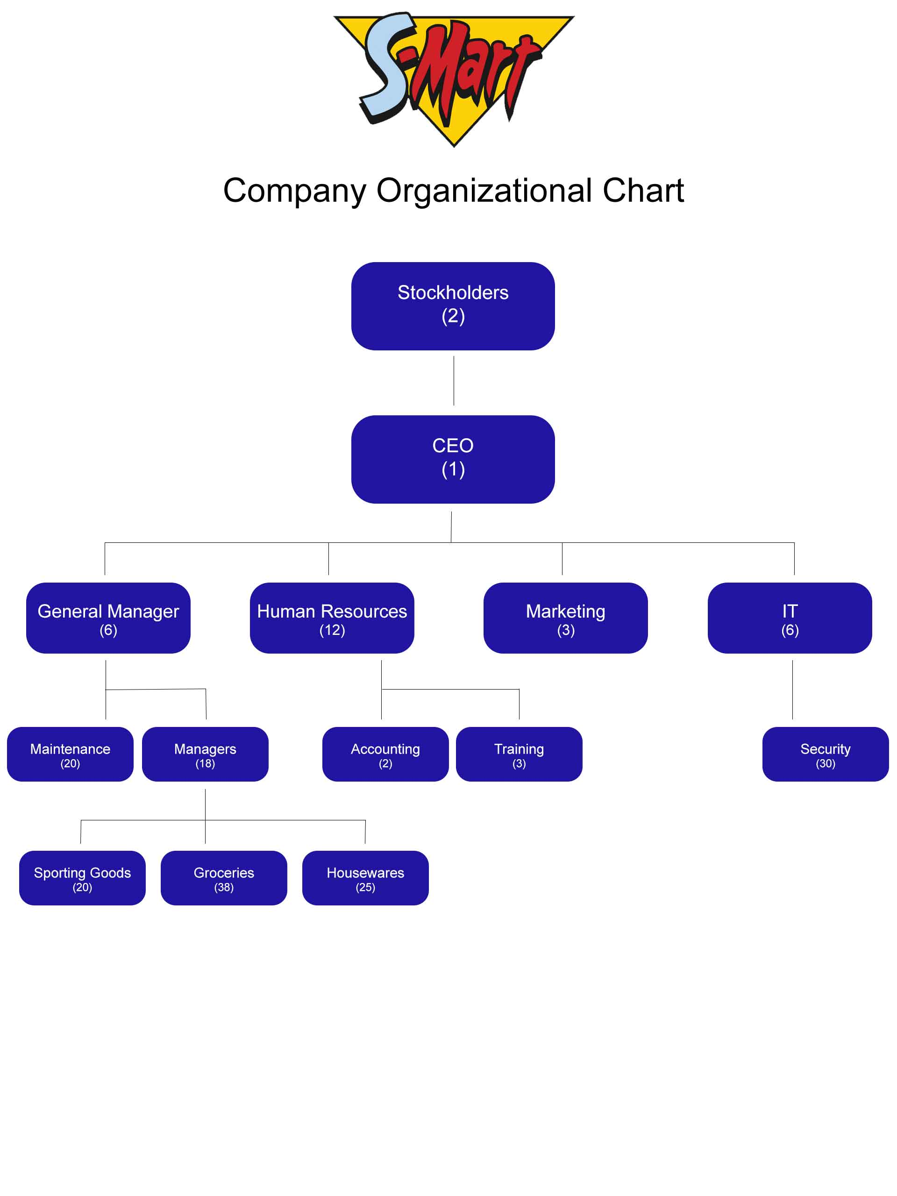

**Operation: Dev Personnel Summaries**

**Aaron Owens, Network Architect & Sales Marketing**

Aaron has a diverse background including Technology, Computer Dynamics, Design Sales, Customer Service and more. He excels in Computer Technology and Networking Concepts using his superior analytical skills, his education in Cyber Security, and his CompTIA certification making him very qualified to fill the role as our Network Architect. With his extensive experience in Sales and Customer Service he manages Operation: Dev’s Marketing as well.

**Mark Lerner, Programmer**

Mark is a results-oriented professional with knowledge in Software Development and Network Administration. He has completed his Software Developer education through Columbus State Community College and has experience with various languages and technologies. His core competencies include Java, JavaScript, HTML/CSS, C#, and Database Fundamentals making him a great addition to Operation: Dev’s Software Development and Database Development.

**Purvik Patel, Programmer**

A second Software Developer for Operation: Dev, Purvik completed his Computer Science education at Columbus State Community College. He has significant experience in C# and ASP.NET making him an asset to the Development Team. He has also gathered various experience in Java, JavaScript, and HTML/CSS helping solidify him as a Developer for Operation: Dev.

**Mahindra Adhikari, Business Analyst**

Mahi is the head of Operation: Dev’s Support Team. He has an education and background as an IT Support Technician making him very knowledgeable in many areas of IT. His expertise across various IT subjects such as Network Support, Desktop Support, Field Technician, and Help Desk procedures allows Operation: Dev to operation most efficiently. His skillset has been a great addition to Operation: Dev as our Business Analyst and Scrum Manager. Mahi is a customer’s first line of support when working with Operation: Dev, and he manages our Agile practices by monitoring and logging tasks or issues.

**Derek Will, Web Programmer & Project Lead**

Derek has a variety of experience in IT, but his focus is Web Development. However, his many years of experience has him filling the role of Project Lead as well as Web Developer. His education is a bit of a mix of topics among Computer Science granting him some unique experience due to this varying exposure, but he acquired a Web Developer degree and Software Developer Certification from Columbus State Community College. His previous experience includes Field Technician, User Acceptance Testing, Web Developer, and UI Developer.

**Create a Work Plan**

To help ensure delivery of any assets, code, updates, documentation, and communication Operation: Dev has a stern work plan that we try to follow. At the same time, we must acknowledge problems will arise and ad-hoc/last minute changes (whether out of necessity or refactoring) so we are an Agile team working in sprints. Our sprints will be completed in one-week increments.

To ensure full completion of each sprint, Operation: Dev will meet every Saturday to review each team member’s progress on the project and to pair program. Team members’ reviews will consist of learning what the team members have completed during the previous sprint and if they need any assistance with any troubles they may have encountered. They will also establish what and how many tasks they will be able to complete during the upcoming sprint.

**Task Management:**

We are using an online based task management/Gantt chart software called Bitrix24 to track the project progress. With Bitri24, Operation: Dev can develop a workplan allowing us to create and assign tasks to appropriate team members to ensure accountability, and scheduled completion. Below is a screenshot of this application with some current project tasks.

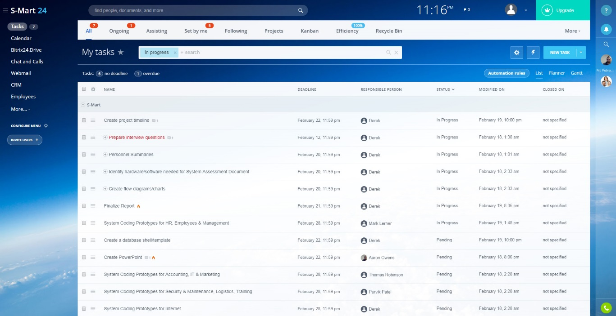

**Project Management:**

To manage the project’s assets and coding, and other files, we have chosen to use GitHub for version control. GitHub is a great way to allow us to work on simultaneously on the project without removing another developer’s coding by mistake. With GitHub, we will be able to split the project up into chunks where the developers will be able to create the separate pages, features, modules, and more much more quickly allowing for a faster live launch. GitHub also provides us with a central location to store the project files to make collaboration simple and more convenient. Below is the S-Mart project repository.

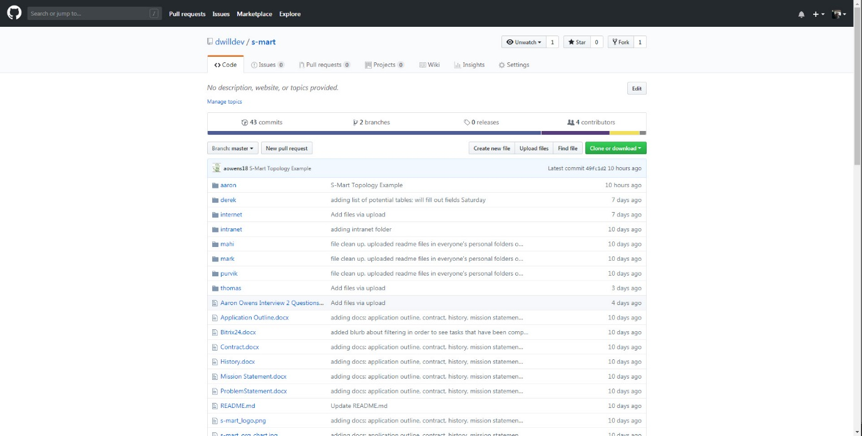

Operation: Dev hopes to complete this project in a rather small window of time. However, we have enough team members to be able to meet our deadline of May 1, 2019.

**Timeline:**

Upon acceptance of the project proposal, the project timeline in Bitrix24 will be completed in fine detail breaking down some of the higher-level tasks, listed below, and assigning them to appropriate team members. Below is the proposed timeline and high-level view of the work load.

|  |  |
| --- | --- |
| February 23, 2019 | Project proposal S-Mart IT solution.  Begin database construction. |
| March 2, 2019 | Coding proof of concepts:   1. Get a working web page online connected to MySQL database 2. Ger a working C# intranet page working online and connected to MySQL Database   Prototypes/mockups for:   1. Screens 2. Reports 3. Queries 4. Error handling 5. Data integrity & validation |
| March 9, 2019 | Provide test plans and test scripts.  Project construction:   1. **Internet** – Construct page template/UI: header, footer, body sections. Create a working index page. Create customer login and access. 2. **Intranet** – Construct page template/UI: header, footer, body sections. Construct the Accounting system, Logistics (Inventory), and HR applications. 3. **Marketing** – Identify 10 items/strengths to promote. |
| March 16, 2019 | Provide security, backup, recovery, restart, and archiving plans.  Continue project construction:   1. **Internet** – Construct a products catalog. 2. **Intranet** – Continue Accounting system, Logistics (Inventory), and HR applications. 3. **Marketing** – Research and implement marketing/advertising strategy |
| March 23, 2019 | Continue project construction:   1. **Internet** – Construct shopping cart. 2. **Intranet** – Construct Marketing, Employees, and Training applications. 3. **Marketing** – Begin advertising mockups. |
| March 30, 2019 | Project mid-way check-in. Present progress and demo working components.  Verify if on track for deadline.  Arrange all system, training, and end-user documentation written thus far.  Continue project construction:   1. **Internet** – Continue shopping cart. 2. **Intranet** – Continue Marketing, Employees, and Training applications. 3. **Marketing** – Begin advertising mockups. |
| April 6, 2019 | Implement S-Mart recommendations from project check-in.  Continue project construction:   1. **Internet** – Application clean up. Continue development. 2. **Intranet** – Application clean up. Continue development. 3. **Marketing** – Continue advertising mockups. |
| April 13, 2016 | Arrange all system, training, and end-user documentation for entire project.  Continue project construction:   1. **Internet** – Construct payment component. 2. **Intranet** – Construct Security, Management, and IT applications. 3. **Marketing** – Finalize advertising mockups. |
| April 20, 2019 | Provide training materials and documentation for system(s) and end-users.  Continue project construction:   1. **Internet** – Continue payment component. 2. **Intranet** – Continue Security, Management, and IT applications. 3. **Marketing** – Finalize advertising mockups. |
| April 27, 2019 | Amend and finalize training materials and documentation.  Continue project construction:   1. **Internet** – Organize all internet project files. Create marketing materials graphics/images from mockups. Complete a code cleanup and/or finish any development necessary. 2. **Intranet** – Organize all intranet project files and combine them into one documentation. Complete a code cleanup and/or finish any development necessary. 3. **Marketing** – Finalize advertising mockups. |
| May 4, 2019 | Review final work and prepare for final presentation of S-Mart project.  Present if necessary. |
| May 11, 2019 | Present live product and all its functionality and features. |

**Project Scope**

**Cost Summary**

Unfortunately, all systems and equipment of S-Mart is quite outdated, so the only option is to start fresh regarding upgrading the network and completing the project. This will include purchasing new computers, servers, switches, software, wiring. The breakdown is as follows:

Store: 700 S-Mart Way, Alma, Michigan 12345

Size: 835 sq. ft

|  |  |  |  |  |  |  |  |  |  |  |  |  |  |  |  |  |  |  |  |  |  |  |  |  |  |  |  |  |
| --- | --- | --- | --- | --- | --- | --- | --- | --- | --- | --- | --- | --- | --- | --- | --- | --- | --- | --- | --- | --- | --- | --- | --- | --- | --- | --- | --- | --- |
| Physical Equipment:   |  |  |  | | --- | --- | --- | | **Equipment** | **Quantity** | **Price** | | Workstation (PC) | 2 | $2,540 | | Laptop (Management) | 1 | $800 | | Router | 1 | $1,550 | | Switch | 2 | $7,200 | | Wire | 1,200 ft | $120 | | Software:   |  |  |  | | --- | --- | --- | | **Equipment** | **Quantity** | **Price** | | MS Office License | 3 | $300 | | Windows 10 | 1 | $100 | |

Store: 100 Main St., Morristown, Tennessee, 37813

Size: 3,360 sq. ft

|  |  |  |  |  |  |  |  |  |  |  |  |  |  |  |  |  |  |  |  |  |  |  |  |  |  |  |  |  |  |  |  |  |  |  |
| --- | --- | --- | --- | --- | --- | --- | --- | --- | --- | --- | --- | --- | --- | --- | --- | --- | --- | --- | --- | --- | --- | --- | --- | --- | --- | --- | --- | --- | --- | --- | --- | --- | --- | --- |
| Physical Equipment:   |  |  |  | | --- | --- | --- | | **Equipment** | **Quantity** | **Price** | | Workstation (PC) | 2 | $6,350 | | Laptop (Management) | 1 | $1,600 | | Router | 1 | $14,400 | | Switch | 2 | $7,200 | | Wire | 1,200 ft | $380 | | Server | 1 | $2,900 | | Software:   |  |  |  | | --- | --- | --- | | **Equipment** | **Quantity** | **Price** | | MS Office | 7 | $700 | | Antivirus | 2 | $16 | | Windows 10 | 1 | $100 | |

Store: 8000 High St., Columbus, Ohio, 43123

Size: 8,400 sq. ft

|  |  |  |  |  |  |  |  |  |  |  |  |  |  |  |  |  |  |  |  |  |  |  |  |  |  |
| --- | --- | --- | --- | --- | --- | --- | --- | --- | --- | --- | --- | --- | --- | --- | --- | --- | --- | --- | --- | --- | --- | --- | --- | --- | --- |
| Physical Equipment:   |  |  |  | | --- | --- | --- | | **Equipment** | **Quantity** | **Price** | | Workstation (PC) | 8 | $10,160 | | Laptop (Management) | 4 | $3,200 | | Switch | 6 | $21,600 | | Wire | 9,000 ft | $900 | | Software:   |  |  |  | | --- | --- | --- | | **Equipment** | **Quantity** | **Price** | | MS Office | 12 | $1,200 | | Windows 10 | 1 | $100 | |

Store: 989 Sure Thing Dr., Oakland, California, 94577

Size: 10,000 sq. ft

|  |  |  |  |  |  |  |  |  |  |  |  |  |  |  |  |  |  |  |  |  |  |  |  |  |  |  |  |  |  |  |  |
| --- | --- | --- | --- | --- | --- | --- | --- | --- | --- | --- | --- | --- | --- | --- | --- | --- | --- | --- | --- | --- | --- | --- | --- | --- | --- | --- | --- | --- | --- | --- | --- |
| Physical Equipment:   |  |  |  | | --- | --- | --- | | **Equipment** | **Quantity** | **Price** | | Workstation (PC) | 10 | $12,700 | | Laptop (Management) | 6 | $4,800 | | Switch | 8 | $28,800 | | Wire | 15,000 ft | $1,500 | | Server | 1 | $2,900 | | Software:   |  |  |  | | --- | --- | --- | | **Equipment** | **Quantity** | **Price** | | MS Office | 16 | $1,600 | | Antivirus | 3 | $24 | | Windows 10 | 1 | $100 | |

Store: 8480 Beach St., Citrus, Florida, 34429

Size: 7,275 sq. ft

|  |  |  |  |  |  |  |  |  |  |  |  |  |  |  |  |  |  |  |  |  |  |  |  |  |  |
| --- | --- | --- | --- | --- | --- | --- | --- | --- | --- | --- | --- | --- | --- | --- | --- | --- | --- | --- | --- | --- | --- | --- | --- | --- | --- |
| Physical Equipment:   |  |  |  | | --- | --- | --- | | **Equipment** | **Quantity** | **Price** | | Workstation (PC) | 5 | $6,350 | | Laptop (Management) | 2 | $1,600 | | Switch | 6 | $21,600 | | Wire | 7,700 ft | $770 | | Software:   |  |  |  | | --- | --- | --- | | **Equipment** | **Quantity** | **Price** | | MS Office | 7 | $700 | | Windows 10 | 1 | $100 | |

Store: 7000 Buttons Ln., Uinta, Wyoming, 82930

Size: 5,250 sq. ft

|  |  |  |  |  |  |  |  |  |  |  |  |  |  |  |  |  |  |  |  |  |  |  |  |  |  |
| --- | --- | --- | --- | --- | --- | --- | --- | --- | --- | --- | --- | --- | --- | --- | --- | --- | --- | --- | --- | --- | --- | --- | --- | --- | --- |
| Physical Equipment:   |  |  |  | | --- | --- | --- | | **Equipment** | **Quantity** | **Price** | | Workstation (PC) | 4 | $5,080 | | Laptop (Management) | 2 | $1,600 | | Switch | 4 | $14,400 | | Wire | 5,700 ft | $570 | | Software:   |  |  |  | | --- | --- | --- | | **Equipment** | **Quantity** | **Price** | | MS Office | 6 | $600 | | Windows 10 | 1 | $100 | |

All Stores:

|  |  |  |
| --- | --- | --- |
| **Total Equipment** | **Total Quantity** | **Total Price** |
| Workstation (PC) | 34 | $43,180 |
| Laptop (Management) | 17 | $13,600 |
| Router | 1 | $1,550 |
| Switch | 28 | $108,000 |
| Wire | 42,400 ft | $4,500 |
| Server | 2 | $5,800 |
| MS Office | 51 | $5,100 |
| Antivirus License | 5 | $40 |
| Windows 10 | 6 | $600 |
| **PROJECT GRAND TOTAL** | | **$182,370** |